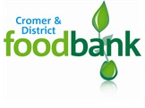
Cromer & District Foodbank,
Methodist Church Hall,
Corner of Holt Rd and Hall Rd,
Cromer,
NR27 9DT

info@cromerdistrict.foodbank.org.uk
www.cromerdistrict.foodbank.org.uk
07826376343

Newsletter for Late Summer 2017

Welcome to the Cromer and District Foodbank Late Summer Newsletter! The aim is to inform you about who we are, what’s going on at the Foodbank and also encourage you to continue to support us.
Cromer and District Foodbank covers an area of approximately 200 square miles, with distribution centres at Sacred Heart Catholic Church Hall, North Walsham; The Stables, Baptist Church, Stalham; St Michael’s Church, Aylsham; Children’s Centre Aylsham; St Joseph’s Catholic Church Hall, Sheringham; Holt Youth Project, Holt; and the Methodist Church Hall, Cromer.
Miranda and Tim are project managing the operation until March 2018 whilst Ella is on maternity leave. They are backed up by trustees and volunteers.
Just so you know, Peter is our Chair of Trustees, Fiona our Secretary, Caroline our Treasurer and Joey, Adrian and Kevin make up the rest of the trustees at present. We are always keen to hear from individuals who would be willing to be considered as a trustee. If so, please contact the office (details at the end of the newsletter).
Ann heads up the volunteer team, Michele leads the van team and Christine leads the voucher team. Each of our centres has a leader and we are extremely grateful to David at Aylsham Church, Judith at Aylsham Children’s Centre, David and Pam at Holt, Adrian and Kay at North Walsham, Jane at Sheringham, Colin at Stalham and Barbara and Maggie at Cromer. At present we have a vacancy for a leader at North Walsham. If you are interested, please contact the office.
Then there are our volunteers, over 100 of them who help in lots of different ways, including warehouse, distribution, driving, administration, website and any other tasks that are required. We are so grateful for their time commitment, their enthusiasm and their desire to help people.
Our mission is to provide short term food supplies to people in crisis who have been referred to us. However, we are also here to help signpost clients towards finding solutions to the issues that are causing the problems. We do not help clients indefinitely, but we work with the agencies through the process of getting people back on track.
In the six months from January to June 2017 we fulfilled 724 vouchers (up from 500 in 2016, which is a 45% increase). These vouchers catered for 1473 people, 996 adults and 477 children. Our donations during this period were 14,693kg up from 11,439kg in 2016 (an increase of 28%). This shows that although donations have increased, demand has increased at a greater rate.

Events so far this year:
In March, Roughton Scouts held a collection for us at Tesco, Sheringham as part of their community badge. Not only that, but they then hiked to Cromer, camped overnight in the Community Hall and served breakfast to the community in the morning. It was a brilliant venture, with 103kg of food collected and £324 raised from donations for breakfast. It was a pleasure for us to present these fine young people with their badges. Particular thanks go to Jenny, their leader, for organising the event.
In April, Tim spoke to Age Concern, Cromer Branch, about the work of the Foodbank and received their donations.
In May we held our first volunteer’s tea party at the Methodist Church Hall. Many of our volunteers were able to join us for tea and cakes and meet trustees and other volunteers. It was a very successful afternoon and we will be holding another event in Spring 2018.
Zumba at North Walsham! We were invited by Sarah who runs the Zumba class at the sports centre to a fundraising event she was organising in July to support Norman Lamb and MIND and also Cromer and District Foodbank. The class were invited to bring in donations and we were there to receive them, watch Norman strutting his stuff and thank everyone for their efforts. We received 93.2kg which was an amazing amount and it was great to see how pleased people were to donate. This event was the idea of one of the class who had need to use the Foodbank in the past and wanted to raise awareness and donate to support our cause. Thank you to Sarah and all the Zumba class. There is talk of another one in the future, we will let you know.
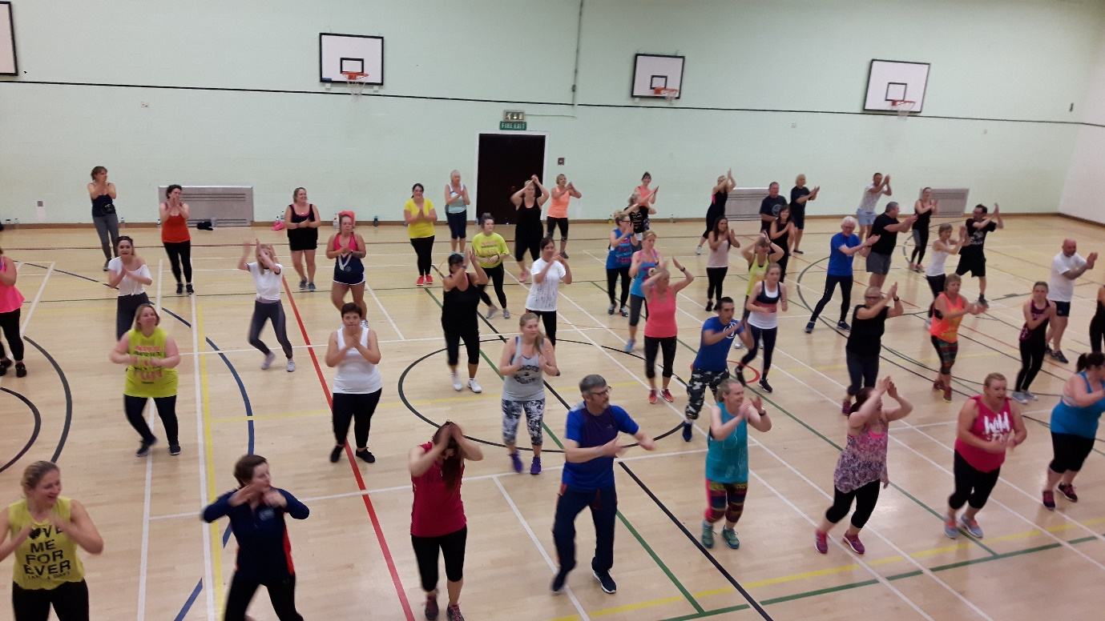
Where’s Norman?
Morrisons collection. Following the successful collection in June and again thanks to community champion Simon, we were able to hold another collection day at Morrisons, Cromer on Wednesday 9th August. A rainy day did not dampen the enthusiasm of shoppers or the team of volunteer collectors led by Ann. An incredible 596kg was donated and over £56 collected in cash. This has made a great difference to our stock levels. Thank you to everyone who supported us.
Cromer Beach Mission held a collection as part of their week in August and the children gave 78kg which was presented to us by Paddy Bennett. Great work guys!

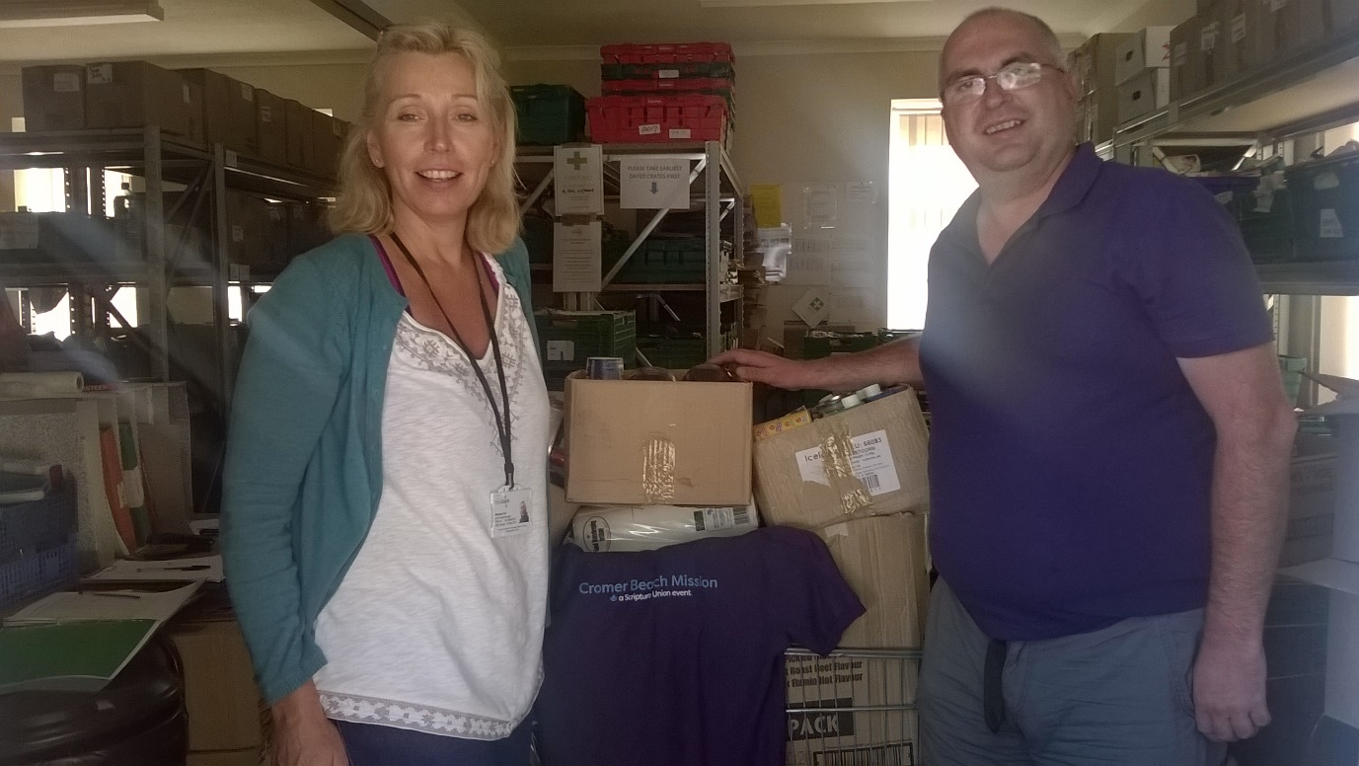

One of the highlights for us this Summer was to receive donations from a 4year old boy who, when inviting friends to his Birthday party, had asked them to bring donation for the Foodbank rather than presents. He proudly helped his Dad bring the boxes into the warehouse. What a wonderful thing to do!

News
We have started a new collection point at Budgens Aylsham. This is being collected as part of a new van run on a Tuesday which began at the beginning of September.
As part of the Trussell Trust More Than Food campaign, we are able to offer financial support through Turn2Us. Turn2Us is a national charity that helps people in financial hardship gain access to welfare benefits, charitable grants and support services. We have volunteers in each of our distribution centres who are trained to assist clients with the benefit checker.
To give an opportunity for working people to volunteer, we are planning an evening warehouse session. Look out for further details later in the autumn. Also we are looking into having alternative off-site storage to cater for our busiest times of Harvest and Christmas. Harvest season is upon us now and we are beginning to receive donations from the schools and Churches who have responded to our Harvest Appeal. Jane has also started to do assembly talks at local schools. We already have other talks booked for Briston WI, Age Concern at Sheringham, Kingsbeck Women’s Group and Chatterbox. If you know of a school, club, Church or any organisation that would like to have someone from the Foodbank come to explain something of the work we do, then please contact the office (number below).

If you have any ideas about ways to support us, thoughts you would like to pass on, or you would like to volunteer, please get in touch with Miranda or Tim on 07826 376343 Monday to Friday 0900-1600 or e-mail info@cromerdistrict.foodbank.org.uk as we would love to hear from you.

